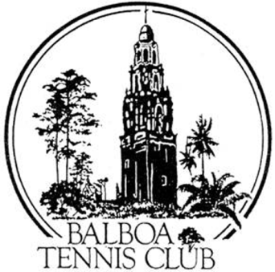
Balboa Tennis Club
Membership Application - Renewal
Please Print when Filling out and Return Entire Form
Name: __________________________________ D.O.B. ________________
Male Female TTTOOOTransgender
Month- Day -Year
Email: ________________________________________________________
Phone: ________________ City__________________________________
Emergency Contact: NAME: Phone: __
Personal Info will not be shared with any other commercial/private entity. E-mail is used solely for communicating Club information and activities.
Do you have a current USTA rating? If Yes - Level: __________
I/ We would like to have / renew Membership at …. (Select from box below)
ADULT | $345 Yearly | $295 Renewal
FAMILY 2 adults w/2 junior level children | $695 Yearly | $645 Renewal
SENIOR 65 years or older | $235 Yearly | $195 Renewal
MILITARY with Military ID | $235 Yearly | $195 Renewal
SUPER SENIOR 80 years or older | $90 Yearly | $90 Renewal
JUNIOR under 18 years of age. | $110 Yearly | $110 Renewal
ANNUAL LOCKER FEE (renewed w/ Membership) | $120 (large) | $60 (small)
ADULT 4 MONTH | $120
Donation to BTC’s Junior Fund BTC Wounded Warrior Tennis Program General Fund $___________
Total Enclosed (Make check payable to BALBOA TENNIS CLUB) $ ___________
Mail to: 2221 Morley Field Dr., San Diego, CA 92104
Additional Info for FAMILY Membership (Name and Date of Birth /Ages for children)
Spouse/Partner Name: ______________________________________________ D.O.B._________________
Children: ______________________________________________________________________________________
I/We would like to volunteer time for BTC Wounded Warrior Tennis Program Tennis Fest
Please Contact Me regarding Sponsorship Opportunities for Tennis Fest Tournaments
BTC Wounded Warrior Tennis Program

