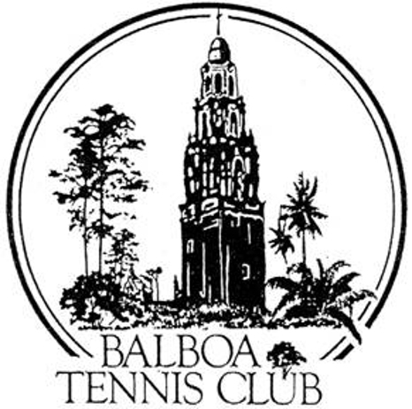
Balboa Tennis Club
Board of Directors Meeting Minutes

April 19, 2016

Meeting called to order at 7:04 p.m

ATTENDEES: Janene Christopher (President), Gary Smith (Vice President), Julia Gregory (Treasurer), Ruben Carriedo, M.A. Hillier, Colleen Clery Ferrell (Club Director), Geoff Griffin(Tennis Director).
ABSENT -Esther Leeflang and Andrew Macfarlane.

The March 2016 meeting minutes and board absences were approved unanimously.

MEMBER/GUEST PRESENTATION - None

President's Comments (Janene Christopher) The ficus tree in front of the Pro Shop has been removed. Suggested siting the existing tournament awning in front of the Pro Shop (where the tournament pavilion will be built). This way we can see how the area will be used until we get the project going.

Tennis Director’s Report (Geoff Griffin)
- Spring Tournament was completed despite threats of rain.
- Tennis Fest funding was partially cut by the San Diego Tennis District, yet Sothern Cal Tennis Association (SCTA) was able to contribute $2000.
- Youth Tennis San Diego (YTSD) which used to operate out of the Barnes Center will no longer be the arm of USTA for junior tennis. SCTA will take it over. Los Angeles will be programming youth tennis for San Diego moving forward.
  - M.A. commented Barnes still allows the wheelchair program at Barnes, but have forced the participants to practice on other courts, away from their shed which is right off the court they were bumped off of. So they semi support the weekly program, but do not support the Hendrickson tournament any longer.
- The upcoming Wounded Warrior Camp is looking great. Guest speakers are being requested.
- Farewell Party for Ron Seno went well. Ron is donating his sound system to the Club when he departs.
- Would like to see Club Picnics start up again. Suggested holding the Holiday Party somewhere other than the BTC Clubhouse and charging a nominal fee.
  - Board suggest asking Pat Mason to spearhead the effort of a Club Picnic.

Club Director’s Report (Colleen Clery Ferrell)
- A note sent to City regarding SUP with help from Ruben. No response from City other than SUP for BTC would be completed soon.
  - Janene will follow up with a call to Todd Gloria tomorrow
- Attended Balboa Park Conservancy Meeting on April 18 in Balboa Park. City officials and stakeholders looking for ways to upgrade all areas of the park.
- At Balboa Park Conservancy meeting, spoke with a Park and Rec manager. He indicated the City was still deciding whether to offer BTC another SUP or a lease.
  - Geoff commented that Pacific Beach Tennis Club was also negotiating with City about their club. Rumor has it that its site will be convert back into marshland.
- Tournament late fee - Tony Perez suggested a $5 late fee per event- Discussion and vote.
  - Board unanimously approved the fee
- New BTC ad for Inside Tennis (created by Janene with input from Colleen & Esther) will be included in May 13 and July 14 issues of Inside Tennis Magazine.
- Board approved morning start times for Hendrickson Wheelchair Tennis Tournament.
- Mandatory Retirement Program will be required starting next year (as outlined by Paychex). Julia requested more information regarding Mandatory Retirement Program

Committee Reports
- Budget and Finance (Julia) The financial package (pg2) “Utilities” shows the financial picture change at BTC. Last March, the cost of the lights at the Club was $6,856 and this march we paid $2,947, a difference of $3,908. At end of 2015 - $2000 was spent on court repair, leaving $22,000 in court reserves for 2016. An additional $10,000 is being set aside in a “Building maintenance reserve”. At the end of 2016, Club should have a good idea on how much it costs to maintain this facility.
- Facilities (Janene) Working on plans for the BTC Veteran’s Tournament Pavilion. Colleen will follow up on patching that needs to be done on court #18 prior to the start of the National Open. Holes in fence on court 13 need to be repaired. Bees have created a hive in hollowed out wood trim – a removal company will relocate the insects within the next 7 days.
- Constitution and Bylaws; Employment and Personnel; Ethics - None

Contract and Lease
- SUP Update – No progress
- Cafe – Ohana Cafe contract on hold pending City SUP decision
Other Issues
- Newsletter – Ready for publication by 5/1
- Fundraising – Janene is meeting with Cami Gil to discuss club fundraising.

Unfinished Business
- Checklist for Clubhouse usage – Approved
- BTC Veteran’s Pavilion – Discussed earlier in facilities
- BTC Contracts – Andrew to compile a spread sheet with all BTC contracts showing execution and expiration dates : still pending

New Business
- Pay Pal account for Club – Paula and Colleen working together to get Pay Pal set up through website.
- Daniel Gradowski membership – No follow up from Daniel.
- Benches for lower courts – The awning areas overlooking the lower courts have been identified as locations for “memorial Benches”. Esther Leeflang collecting contributions to purchase bench in honor of Muan Knight.
- Court resurfacing for 2016 – Six courts approved for November 2016

Adjournment: 8:20 p.m. The next board meeting will be May 17, 2016

