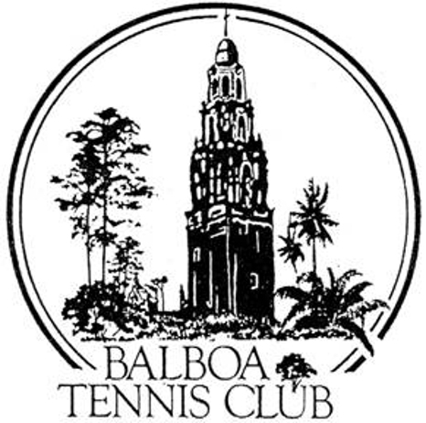
Balboa Tennis Club
Board of Directors Meeting Minutes

April 17, 2018

Meeting called to order at 7:05 p.m.

Attendees: Janene Christopher, Gary Smith, Julia Gregory, M.A. Hillier, Andrew Macfarlane, Ruben Carriedo, Esther Leeflang, Geoff Griffin and Colleen Clery Ferrell.

The March 2018 meeting minutes were approved unanimously.

Member/Guest presentation – Tom Metroyanis, John Meyers and Dianne Greenwood from Sustainability Funding Program for LED light installation gave a presentation to the board. They verbally proposed a plan for BTC to install fixtures and decrease BTC electricity consumption by 40%. The basic premise of their plan is energy savings. With 8 courts that have adequate light, 17 courts at BTC still need retrofitted LED lighting. Similar to many of the other companies examined, the Club would still have to take out a loan to initially finance the LED lights through this program. At this point, the Board is hoping to get donated funds instead of financing the LED lights.

President's Comments (Janene Christopher) –
- Press Pavilion update – The City approved drawings. Next step is to submit plans for permit. Hope to break ground after tournament season in November.

Tennis Director’s Report (Geoff Griffin)
- BTC Spring Tournament was a success, even though BTC was competing with a sanctioned tournament in Pacific Beach. Financial numbers will be included in May meeting. Format with 10 point tiebreaker in lieu of 3rd set helped with court management. Next year matches will start Friday to improve scheduling and Geoff will add a 4.0 division.
- Wounded Warrior Camp to start May 6. The committee is reaching out to the members to help Manuela, who is in charge of providing food for the camp.

Club Director’s Report (Colleen Clery Ferrell)
- M.A. created excel format with list of league team captains. Colleen completed the list which is now available at the Reservations Desk. This document provides members who are interested in joining teams several options of contact.
- Friday Mixed Doubles Event to be held 1st and 3rd Friday evening of each month on courts 7- 10. BTC member Christy Turner is organizing the doubles.
- Emergency Action Plan – will review and revise with Janene’s suggestions for next month’s board meeting.
- Membership totals remaining consistent at 1326.

Committee Reports
- Budget and Finance (Julia)
  - Last month mostly on budget. Utilities higher than budgeted amounts.
  - Bank balance lower due to $20,000 paid to install LED lights on courts 9&10.
  - Maintenance costs lower than budgeted.
- Facilities
  - Julia and Colleen walk the grounds regularly to view and plan maintenance needs. Painting in Reservations area has been the core of recent maintenance work at the Club.
- Employment and Personnel – New Reservations Desk employee Liberato “Bert” Lara starting to work one weekend per month. Robert Pe requesting time off.
- Ethics – None

Contract and Lease

- Cafe – Guillermo still waiting on health department approval. Should come soon. Still working on bringing Café up to code to pass the test the first time.
- Lease – Lease with City expires 5/1/18. Process of renewal/renegotiation has not yet begun. Andrew is writing letter of Indemnity for Club regarding tenants using rooms in Reservations building – GSDCTC, SDDTA and Griffin Tennis.

Other Issues
- Newsletter – Will be published in May
- Website – Additional 2018 tournament links to be added.
- Advertising/Public Outreach – None
- Fundraising - None

New Business

- David Ross - Memorial to be held May 12. Board considering a plaque or water fountain be dedicated in his honor.
- Biking Through BTC – Esther has witnessed BTC member Stan Jankowski continually ride his bike through BTC. She suggested he needs to receive a letter from the Board to curb this behavior. Esther also mentioned she will represent BTC in Kensington Memorial Day Parade.
- Instagram Posts on social media - Employee David Saranglao is posting social media updates for Instagram and Twitter. Board approved providing a new phone for better photos and updates. Esther will put together guideline of posts for David.
- OLP Summer Camp – Coach is requesting to hold one week summer camp for team members and incoming players. Discussion as to Griffin Tennis role, certification and insurance for pros at camp. Colleen will follow up with OLP Coach Karen Karoub

Adjournment: 8:40 p.m. Executive Session to follow

Next board meeting will be May 15, 2018

