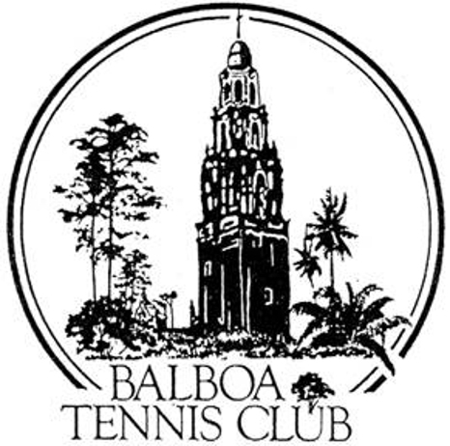
Balboa Tennis Club
Board of Directors Meeting Minutes

December 20, 2016

Meeting called to order at 7:02 p.m.

Attendees: Janene Christopher (President), Gary Smith (Vice President), Julia Gregory (Treasurer), M.A. Hillier, Colleen Clery Ferrell (Club Director) Andrew Macfarlane (Secretary) Julie Prichard (Social Media Director).
Absent: Esther Leeflang, Ruben Carriedo and Geoff Griffin.

The board member absences and November 2016 meeting minutes were approved unanimously.

Member/Guest presentation – None

President's Comments (Janene Christopher) - None

Tennis Director’s Report
Holiday Gift Drive - Julie Prichard reported that Geoff Griffin and many of the BTC junior players purchased presents, stuffed stockings and prepared all the presents for delivery. Gift Drive was a success.

Club Director’s Report (Colleen Clery Ferrell)

- Director’s coverage for employee meals and breaks –Working hours will vary due to coverage for reservation attendant in evening for meal time break.
- Donations from members for additional canopy – Four BTC members donated money to purchase an additional canopy (area between courts 8-9). Members : Todd Linke, Kay Davies, Steve Hon and Larry Calder
- Family Membership Pricing for 2017 – Pricing will be adjusted reflect difference from 2 Adult renewal fee. Two adults will be able to renew under Family rate.
- Gardening cutback for January and February 2017 – Due to excessive rain, there is no need for two landscapers. For the first two months [Jan & Feb], Dan will cover all duties. Melissa will return in March.
- Day pass totals, membership tally – Primary usage coming from locals who use the Challenge Court, followed by former members, people on vacation and those who found the Club through a Google search. This tally will only be presented quarterly.
- Daily Log Report – Members and Griffin Services employees and Customers have been regularly harassed by an African American man (with racquet in bag. Has not harmed anyone but has been verbally demanding. Board Direction; “keep a watchful eye” on him.
Committee Reports

- Budget and Finance (Julia)
  - The balance sheet shows $124,000 in the bank.
  - December expense include payment for court resurfacing balance will be at $110,000 at the end of the year.
  - 2016 finances were reviewed and analyzed. Last year’s budget under-estimated the maintenance and over-estimated the utilities.
  - 2017 Budget will include the following :-
    - $30,000 for court resurfacing.
    - $1200 for charitable donation to Griffin Tennis service’s Junior Fund.
    - $2160 for “free, non- member clinics [to attract new members].
    - Human Resource consulting from Dianne St. John is being budgeted to keep current with state and federal changes for employment.
    - Approved payroll increases and 401 K matching funds contributions were also budgeted.
- Repairs and maintenance remains the big unknown. Last year $12,000 was budgeted and the Club ended up spending $37,000.
- Board will vote at the January meeting to adopt the 2017 budget.
- Facilities (Janene) The bleachers (at Ct 18) could be sandblasted and repainted for $2000, Start Date- January 2017 [by Charles St. Hill]. Board Vote: Approved
- Constitution and Bylaws – None
- Employment and Personnel – Executive Session.
- Ethics – Executive Session

Contract and Lease

- Cafe – Board is waiting for confirmation from Becky Kuba that Café will be open consistently on Saturdays starting in January 2017 from 9:00 a.m. – 2:00 p.m.
Café will also be operational during all tournaments and special events.
Chalk board outside the Café must be updated to reflect new Saturday opening and operation times.
Existing banner need to indicate this Café NOT the La Jolla location.

Other Issues

- Newsletter – December 2016 publication. Next newsletter in May 2017
- Website – Update to the Family Rates

Unfinished Business

- Tournament Pavilion plan and naming rights – Volunteer Designer has not has time to work on the design. This item will be tabled till February 2017.

New Business

- Artwork on Electrical Box – Club received permission from the City to create art design on electrical box by court 8. Julie Prichard recommended tennis pro Armando Sandoval’s daughter as a possible “artist” done under Julie’s guidance. Julie will follow up with the project.

Adjournment: 8:10 p.m. Executive session to follow

The next board meeting will be January 17, 2017

