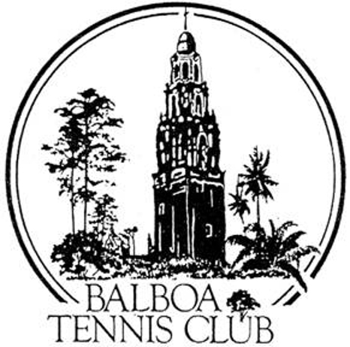
Balboa Tennis Club
Board of Directors Meeting Minutes
December 18, 2018

Meeting called to order at 7:00 p.m.

Attendees: Janene Christopher, Gary Smith, Andrew Macfarlane, Remy Serrano, M.A. Hillier, Ruben Carriedo, Todd Linke, Colleen Clery Ferrell and Geoff Griffin were present. The November 2018 Meeting Minutes and Executive Session were approved unanimously. MMS&C

Member/Guest presentation – None

President's Comments (Janene Christopher)
- Press Pavilion/Canopy update – Plans for the Press Family Pavilion/Canopy were approved from five departments of City of San Diego Plan Check. Ready to pull the permit, yet need final ok from Park and Recreation before moving forward.

Tennis Director’s Report (Geoff Griffin)
- Annual BTC Holiday Gift Drive supporting Storefront and Stand Up For Kids went well, as members were very supportive.
- Ball recycling for 2019 will cost $50 per month. Geoff asking Club to pay for the fee. Item will be considered with upcoming 2019 budget.
- Geoff requesting Club to participate in Adopt-A- Unit program in January or February. Items requested to be sent overseas to military personnel include beef jerky, candy, nuts, etc.
- Tennis Fest slated for Sunday, June 9 at BTC this year.

Club Director’s Report (Colleen Clery Ferrell)
- A new AED for the Club has been approved. San Diego Project Heartbeat has offered a 10% discount with purchase.
- Annual Turkey Shoot Social in November 2019 will combine with Wounded Warriors Social as last one was very successful. Upcoming year needs to be a budgeted item because there is cost to the Club involved.
- Colleen read a complimentary thank you note from CIF administration.
- Anticipating additional foreign players will be participating in National Open 2019 due to merging of USTA and ITF point systems.
- For the first time in a long time, there were no mentionable Daily Log notes. Membership – Numbers were down this month from 1372-1336 as 90 members were on the expiration list. Each one was personally notified by staff and disabled from online access. Hoping to recoup lost revenue in month of December.

Committee Reports

- Budget and Finance (Colleen)
  - $119K in the Club bank account. Starting in 2019, the Club will keep a 50 K base in bank account and work up to 50K in reserves. Currently Club has a 39K base in reserves. Membership down $4558 in month compared to 2017 and off $3572 budget to actual. As mentioned above, this is a reflection of 90 members on expired list who didn’t renew on time.
  - Hard to compare 2018 income to 2017 because Club received 11K pen ultimate donation from deceased member’s estate in month of November, 2017.
  - Social event expense high for 2018 due to food and entry fees that were donated to Wounded Warriors this year from BTC.
  - Other expenses in line. Club budgeted to lose $8,891in the month of November and ended up losing $8238.
  - 2019 budget to be voted on at January meeting. Wage increases and cost of living items will be accounted for prior to voting on final budget.
- Facilities – All three windscreen improvements were approved for cost of $6180. MMS&C.
- Constitution and Bylaws – None
- Employment and Personnel– None
- Ethics – None

Contract and Lease

- Cafe – Still waiting on final paperwork from the Health Department.
- Lease– Special Use Permit with City of San Diego expires 5/1/19.

Other Issues

- Newsletter– Next publication May 2019.
- Website– None
- Advertising/Public Outreach – None
- Fundraising – Spring Tournament to be dedicated to Upper Court Lighting Project which includes LED lighting for courts 1-8, 11-18 and the stadium. Thermometer will be posted for members to see gradual increases in funds. Two courts can be upgraded in 25K increments. Overall project costs 180K.

Unfinished Business

- OLP Track Team – No reply to offer made by BTC for restroom usage.

New Business

- Holiday Party – Date for 2019 party switched back to mid week due to conflicts with other holiday parties and December Nights in Balboa Park. Projected date: Wednesday, December 11, 2019
- Contractor’s Request – Maintenance contractor Charles St. Hill requesting to play tennis at BTC. Board decided to allow St. Hill to play during non-prime time. No reservations can be made. This is a one year allowance.
- Environmental Responsibility – After discussion, Eco plastic cups will still be handed out at the Reservations Desk for members and the general public upon request.

Adjournment: 8:05 p.m. Executive Session to follow

Next board meeting will be January 15, 2019

