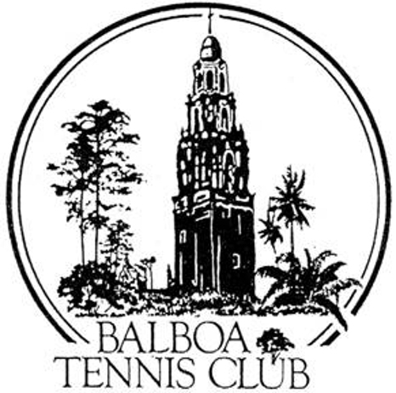
Balboa Tennis Club
Board of Directors Meeting Minutes

February 21, 2017

Meeting called to order at 7:00 p.m.

Attendees: Janene Christopher, Gary Smith, Julia Gregory, M.A. Hillier, Andrew Macfarlane; Esther Leeflang, Ruben Carriedo; Colleen Clery Ferrell, Geoff Griffin and Julie Prichard.

The January 2017 meeting minutes were approved unanimously.

Member/Guest presentation – none

President's Comments (Janene Christopher) –
- Club Roof – the roof is leaking and needs repair. Suggest getting entire roof re-roofed. Colleen in process of getting bid and she has been in touch with Susan Mendoza (Park & Rec) the City. City will send someone out to evaluate and patch or replace as needed. Club handyman [Charles] will repair roof for weekend showers.

Tennis Director’s Report (Geoff Griffin)
- Junior tournament went well. Some delays due to rain and final was held on Monday
- NIBCO corporate event will be held March 5th from 7am to noon. Catering [Ohana] and a round robin tournament are planned.
- Issues with students in junior development program. Parent e-mailed BTC/Colleen. Colleen responded that this was under Griffin Tennis. Issue resolved by Griffin Tennis /Afini Tennis.
- Courts 11 and 12 may be used for Griffin Tennis from 3-5 pm Monday through Friday if the courts are available. Saints’ season is starting and courts may be needed for members.

Club Director’s Report (Colleen Clery Ferrell)
- Jack Grace’s trust is scheduled to be liquidated in 2016. BTC is expected to receive a significant gift by Nov.
- Online Reservations: In touch with tennisbookings.com regarding the options and implementation. System will cost $95 per month and will be in addition to call in and in person reservations. Call in and in person reservations will continue as they are now. Eventually reservations will be “paperless”. Discussion: who may reserve (all members) and what to do with no shows. (more discussion needed). Implementation will require several steps. Training sessions for interested members will be provided when the system is ready to be put online.
  - Motion made to implement online system, Vote: unanimous.
- Don Dudley has been providing assistance for membership database– he is a MS Access expert. Don’s help is needed to transition the Access info to upload to tennis booking site. Don’s fee $50/hr.
- Intern Hendrik Jebens is new Club intern. Smart helpful young man who will be around through May. Positive reviews from Geoff
- January’s renewal notices for memberships were not received by members. This caused a significant drop in membership renewals. Made 68 calls to members regarding renewals and many memberships were immediately renewed. The personal call may be a new tactic in getting renewals done on time.
- This year the Girls 16/18 National Tournament will hold some matches at BTC August 5-8. Eight courts for [4] four days. The main site for the tournament is Barnes Tennis Center. Tennis Director suggested we ask for main draw matches such as a doubles draw so BTC does not host only consolation rounds. Will contact Tournament Director and advise Board.
- Daily log & Membership Totals reviewed – Membership total at 1180 despite losing some renewals likely due to renewal notices not received.

Committee Reports
- Budget and Finance (Julia)
  - Income lower than expected due to low membership renewals. Membership renewals recovered due to club directors calls and are expected to rebound the following month as notices are sent.
  - Club budget healthy. $200 off the target budget.
- Facilities (Janene)
  - Club roof discussed earlier
  - The bleachers next to court 18 are completed and look good.
  - .Lighting [LED] bids received. ReGreen still has best deal.
- Constitution and Bylaws – None
- Employment and Personnel
  - Sean Ortuno is covering for David and Alex during CPR training which will happen later this week and is also filling in when needed at Reservations Desk.
- Ethics (Gary)
  - A new org chart was presented. Discussion: Organizational flow revisions were recommended to show the relationships of City, Board, Club Director, Tennis Director and Café. Revised chart will be re-issued.

Contract and Lease

- Cafe – The café is open depending on owner’s outlook for each weekend. Café has been closed recently as weekends have been rainy. Geoff noted that there was no food available during his junior tournament and that kids and parents were looking for food. Geoff asked if a snack machines or coffee cart could be brought in for the times café is not open.

Other Issues
- Newsletter – Next newsletter in May 2017
- Website – Currently website includes links to USTA sanctioned tournaments only. Director will update website with tournament and event schedule with USTA links when available.

Unfinished Business
- Webcam on Court – quote for webcam with live stream to show court conditions would cost $5,000. No motion to move forward with this.

New Business
- Club Wayfinding Sign – The old wayfinding sign by court 8 showing club layout and court locations is not looking good. A new metal sign will be made to replace the old one.
- Club Board Members & Pros - A new board with tennis pros, [their biographies] along with director and board members photos will be placed in the clubhouse. Tennis pros bios will be edited by Geoff to insure they are all written in a similar manner.
- Challenge Court Sign – new sign will be placed at ultimate challenge court with updated rules.

Adjournment: 8:23 p.m.

Next board meeting will be March 21, 2017

