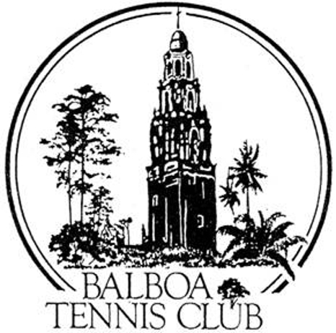
Balboa Tennis Club
Board of Directors Meeting Minutes

February 18, 2020

Meeting called to order at 6:33 p.m.

Attendees: Janene Christopher, Gary Smith, M.A. Hillier, Ruben Carriedo, Todd Linke, Andrew Macfarlane, Michelle Ford and Colleen Clery Ferrell.

The January 2019 meeting minutes - were approved after a discussion on the procedure. In the future, all changes suggested by board members will be reviewed by the secretary and resent to the board members prior to final approval at the board meeting. MMS&C

Member/Guest presentation – None

President's Comments (Janene Christopher) Company Michelle recommended had machine & work load issues and are unable to submit a bid. Currently have bids from 4 fabricators for $10,800 $7500, $6582 and $4202. The $6582 bid from Megla Manufacturing – the company that made the Press Family Pavilion tennis ball roof – is for an all-aluminum gate which is different from other bids. Will ask them to resubmit a bid for all steel construction. Will get a revised bid and distribute to Board. .

Club Director’s Report

- USTA Grant Decision for LED Lighting of courts 1,2,11,12 – BTC has been awarded a 20K grant to add LED Lighting to courts 1,2,11,12. BTC must first install padding to light and awning poles on courts 2 and 12 because of the distance from the poles to the court end lines does not meet up to USTA codes. Club will inquire whether USTA will finance cost of padding as well.($2500)
- USPTA – United States Professional Tennis Association- will be awarding BTC “Club of the Year” on March 8 at their annual San Diego Division Meeting at La Jolla Beach and Tennis Club. USPTA is a tennis teaching organization.
- Upcoming Social – On April 11, the Club and Griffin Tennis will organize a fun social for the members including round robin tennis, food and music.
- Report on Membership Totals and Daily Log Review - 1497 members after the month of January. Membership is very high at this time due to favorable weather.

Committee Reports
- Budget and Finance (Colleen)
  - $104,926 in the bank at the end of the year.
  - Profit and Loss for the month of January shows memberships up with an overall increase of income at $9071 over 2019. BTC attendant Alex Djordjevic claims that “locking out” delinquent members from using the online system has helped provide incentive for members to renew on time. Also personally phoning each member on the expiration list has enticed many people to rejoin. Total income for January 2020 - $10,733; $8435 over January 2019 which was a rainy month.
  - 2020 Budget to Actual Report for the month of January, shows a positive gain of 11K in memberships and court rental income, with expenses in line. Net income $10,828 over budget.
  - Monetary allocation for shading, LED Lights, teaching court lights and designated annual resurfacing. New shading on courts 19-21 to be completed from 5K contribution provided by M.A. Hillier. The Board acknowledged and thanked M.A. at the meeting. LED lights on courts 5-8 and 13-18 paid for from 100K donation by Una Davis. BTC will pay for courts 11-12 from fundraising the past few years. Teaching courts 1-2 will be funded by USTA after completion, leaving teaching courts 3-4 and the Stadium still in need of lighting upgrades. Resurfacing for courts 5&6, 15&16 scheduled for November 2020 from BTC reserve funds.

- Facilities
  - Canopies for courts 19-20, 20-21 are ordered.
  - LED Light Project – details of staging area explained, 10 year warranty on lights, insurance from G-Force Electric on file and tentative schedule presented.
  - Padding for courts 2, 12 in order to qualify for grant funds. (Discussed under Club Director’s Report)
  - Water bottle filling station was not delivering a strong, steady stream water during early morning hours. Manufacturer suggested the cause as a tank freeze. Temperature increased to see if adjustment helps.
- Constitution and Bylaws - None
- Employment and Personnel – None
- Ethics – A recent incident on the Ultimate Challenge Court received complaints from both parties involved. A young 10 year old boy was competing with his father. A former board member cited this as being wrong as the young boy was not at the required 4.5 level and complained. The father of the boy stated his son should be allowed to play on the Ultimate Challenge Court when the level was low. The Board decided the 4.5 NTRP level and 7.0 plus UTR rating must be enforced by desk staff.

BTC Vendor Report
- Cafe – Open seven days a week and beginning to pick up local business.
- Griffin Tennis – Geoff is confident USTA will pay for required padding on courts 2 & 12.
Other
- Newsletter – Moving up due date to April. Ruben agreed story on his assistant coach Walter Redondo would be newsworthy. No other article suggestions.
- Website – None
- Advertising/Public Outreach – None
- Fundraising – None

Unfinished Business – Donor Brick Program – Restarted the program with new pricing.

New Business

- Clubhouse Usage –
  - Review of policy for Group Meetings/Gatherings:-. The Club allows free usage of the Clubhouse to the following groups:- San Diego County Umpire Association; the Wounded Warriors and on occasion the United States Tennis Association.
  - Ruben asked earlier in the meeting for an addendum to the BTC Food Policy in the Clubhouse. Groups of five who are reserving the clubhouse and/or holding a function must purchase from the Route 6 Cafe. Individual and small groups may bring in their own food.
- Donation and Naming Opportunities at Balboa Tennis Club – A BTC member asked the Club Director for a list of these items. Colleen presented the list to the Board and thanked the board members who have contributed financially to the Club. The following items were listed :- a new table in the men’s locker room, audio system for Press Family Tennis Pavilion;
Awnings on lower courts 22-24, Upgrades to the Stadium Court – shade and seating, two additional benches above courts 19 and 22, LED Lighting Upgrades on the stadium and courts 3-4, new ice machine with water bottle filler, resurfacing of all courts and an upgraded surveillance video system for the Club.

Adjournment: 8:25 p.m.

Next board meeting will be March 17, 2020

