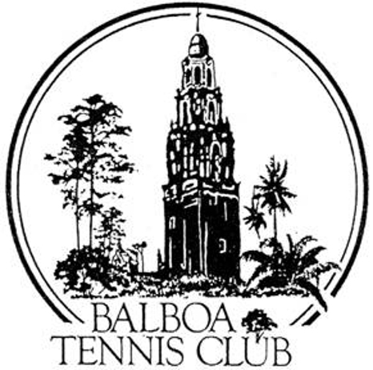
Balboa Tennis Club
Board of Directors Meeting Minutes

July 18, 2017

Meeting called to order at 7:04 p.m.

Attendees: Janene Christopher, Gary Smith, Julia Gregory, M.A. Hillier, Esther Leeflang, Ruben Carriedo and Colleen Clery Ferrell.
Absent: Andrew Macfarlane and Geoff Griffin.

The June 2017 meeting minutes and absences of were approved unanimously.

Trent Aaron was not on the agenda due to a miscommunication with Colleen Ferrell.

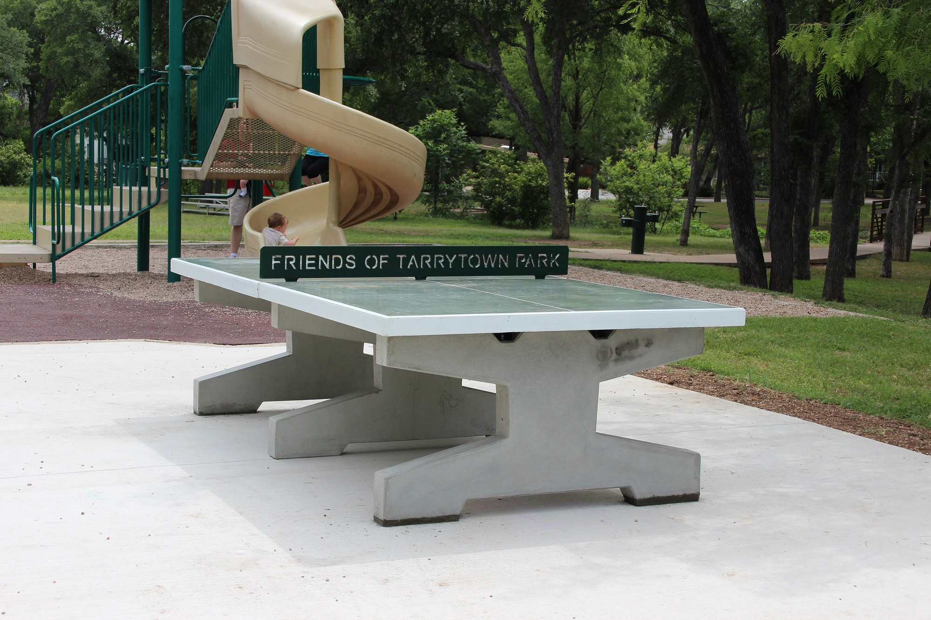
Member/Guest presentation –Trent Aaron:
Would like to raise funds (via GoFundMe or some other Crowd Funding site) for a concrete ping pong table, which generally cost $10,000. Very sturdy and vandal resistant, even to graffiti due to coating which can be wiped off. One possible location would be between Ct 18 and Stadium. The tables are also wheelchair friendly.

Colleen will send link for concrete ping pong tables to board members.
San Diego Park and Rec Dept., and Friends of Balboa Park will need to be contacted for approval before BT’s involvement.

President's Comments (Janene Christopher) – Nothing new to report on court lights.

Tennis Director’s Report (Geoff Griffin) – Absent - Preparing draws for the BTC Open and BTC Junior Tournaments.

Club Director’s Report (Colleen Clery Ferrell)
- 2017 National Open financials and tournament notes were presented. Club netted $2452 from the tournament and overall tournament was a complete success. Reviewed the tournament notes and details at Julia request.
- 16-18 Girl’s Nationals will be at BTC next month. There will be high demands made of the Club/Staff by that group and patrons. It will be great junior tennis action.
- Friends of Balboa Park – The tree dedicated to member Pat O’Reiley was killed due to root rot (irrigation leak that wasn’t fixed by the City in a timely manner). A replacement tree was requested and approved by City. Moving forward, all dedicated trees in Balboa Park must be approved and include a fee of $500 for the Friends of Balboa Park.
- Insurance documents from Pros and Griffin Tennis were received. All pros and Griffin Tennis have valid/up-to date insurance coverage.
- Report on membership totals and Daily Log – Membership is steady at 1174.

Committee Reports
Budget and Finance (Julia)
- At the half year point, the Club has a $222,000 gross profit and expenses come in at $184,000. The income is up due to Jack Grace’s contribution, membership and tournament income. Specific items that should be reviewed regularly :
  - Membership up $5000,
  - Permits down $2000,
  - Court maintenance expense at $3200 with budget of $4700,
  - Office expense up to $4300 with a budget of $2950 due to implementation of online reservation system,
  - Facility repair and maintenance – spent almost $14,000 with a budget of $15,000.
For June, court expense was budgeted at $773 and $1468 was spent due to purchases for net dividers (the old tattered ones were replaced).
Requests early look at monthly financials and questions Colleen on items which seem excessively over or under budget. This way “budget” vs “actual” is kept in line.
- Facilities
A. Clubhouse Chairs – Board & Members seem happy with reupholstering. Cushions can now be flipped
B. Roof Estimates – Julia met w/ Chris Ward’s Office and reported that the City has not designated BTC for a roof repair. Susan Lowrey Mendoza said they only add two new roofs to City buildings per year.
Colleen received two widely diverse bids. One would fix the leaking area $1350 and offer a one year guarantee. The other bid is over $5000. Board decision is to prepare a RFP (Request for Proposal) and have Colleen get three or more proposals before the next board meeting. BTC will make a case to the City citing how the Club wants to protect $130,000 remodel from further damage due to roof leakage. New roof may also be put into 2018 capital budget depending on City decision whether to help BTC financially with roof repair.
C. Sidewalk Signs – Board discussed this exact verbiage with resolution. Colleen with pass the revisions on to sign maker.
- Constitution and Bylaws – none
- Employment and Personnel – Rob Abbott has returned to Club from Michigan after extensive health issues. There is no opportunity for employment at this time. Board offered one month complimentary membership as goodwill gesture.
- Ethics – none

Contract and Lease
- Cafe –
  - Ohana struggling to be operational for the remainder of BTC’s tournaments. Board is “hoping” they will be open for Balboa Open.
  - New/Prospective cafe operator was sent copy of previous Cafe permit to get idea of terms and insurance needs.

Other Issues
- Newsletter – Next newsletter to be published November 2017
- Website – None
- Advertising/Public Outreach – Aviator Tickets being sold to club members for BTC Night at La Costa.
- Fundraising – none

Unfinished Business
- Clubhouse roof – Previously discussed in meeting
- Tournament pavilion – Esther’s brother-in-law, Charles Roberts – a Design/Build Architect has been offered opportunity to complete the pavilion process. Janene will contact him to see if he is interested in moving forward. Ben Press family wants to see Pavilion Construction Documents before their involvement.

New Business
- Proposal from High Schools for CIF tournaments to be held at BTC - CIF request approved by Board. Rate will be $5hr per court, all used balls will be donated to Griffin Tennis youth programs and Courts will be returned trash/gum free/sticky drink spill free. This approval for use is one way BTC can step up and serve Youth Tennis San Diego.

Adjournment: 8:40 p.m.
Next board meeting will be August 22, 2017

