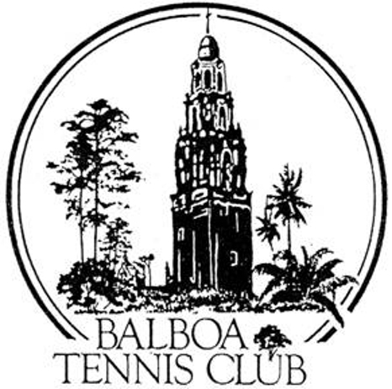
Balboa Tennis Club
Board of Directors Meeting Minutes

June 20, 2017

Meeting called to order at 7:00 p.m.

Attendees: Janene Christopher, Gary Smith, Julia Gregory, M.A. Hillier, Andrew Macfarlane, Esther Leeflang, Ruben Carriedo; Colleen Clery Ferrell, and Geoff Griffin.

The May 23, 2017 meeting minutes were approved unanimously.

Member/Guest presentation – Dave Felice spoke on behalf of his request to rejoin the club. Dave was expelled from BTC in 2011. Since then, he has played at La Jolla Rec and Coronado. Dave detailed his disabled veteran status and acknowledged issues in the past. He stated he took an anger management course in 2014 and now is a new person. He stated his attitude is changed and he no longer argues with other players. Dave brought a letter from Scott Farr, the manager at La Jolla Rec that confirmed Dave’s membership and good standing at the club. He requested membership for a probationary period to show that he is capable of complying with the club rules. Dave misses playing tennis at BTC, especially at the Challenge Court. Several board members asked Dave whether he had any recent issues at La Jolla Rec and he denied encountering any problems. The Board thanked Dave for coming to the meeting.

*Decision after discussion and background information: The Club asked for confirmation of Dave Felice status from La Jolla Rec. Our decision was based on that response. Dave Felice denied membership.

President's Comments (Janene Christopher)

- Facebook complaint about Challenge Courts. Person complained about low level of play on all Challenge Courts. Colleen backed up confirmation of complaint and stated it was true, yet hard to please everyone. She stated that the majority of people who use the Challenge Court enjoy the competition.

Tennis Director’s Report (Geoff Griffin)

- Tennis Fest – Geoff no longer leading but BTC will continue to host.

Club Director’s Report (Colleen Clery Ferrell)

- National Open Hard Court Championships were best ever overall in her 12 years of running the event. Highly ranked local juniors entered and brought up the level of play. More fans than previous years and great media presence each day of the tournament.
- Dr. Soloway talks were a success. He inquired about giving on court instruction but he does not have requisite insurance. No on court instruction planned.
- Bicycles and scooters on the sidewalks within Club premises have become a nuisance. Signs to be posted limiting bike/scooter/skate use in pedestrian areas of club.
- Shade estimates for courts 1 and stadium - $4,995 total. This includes shades, structures and construction costs. Julia made a motion to approve and said motion was approved unanimously.
- Board member Ruben Carriedo recognized at Lincoln High School where tennis courts were dedicated to him. Colleen and other members attended the dedication.
- New USTA rep Randi Lettington requesting league coordinators at BTC, yet no decision made on appointing them. Seasonal captains such as Mark Bauer and Esther Leeflang are willing to answer league questions without actual designation.
- BTC is 78 years old as of June 19 this year. The club moved to its current location in 1963.
- Membership is up to 1232.
- Scientology rented courts for a morning video shoot. Club netted $400.

Committee Reports
Budget and Finance (Julia)
  - Club is on target for budgeted income and expenses. Missed key on Budget vs. Actual for month of May by accountant caused membership for month to be off.
  - $10,000 donation from Jack Grace fund increased income for the month.
  - $148,000 in bank, well above $50,000 target in part due to recent donation received.
  - Plan is to resurface 6 courts later this year and pay for lighting out of general fund rather than finance, hopefully starting with two courts to showcase at year end.

Facilities (Janene)
  - Lighting proposal expected to be done in the next month. LED Lights at Scripps Ranch Swim and Racquet Club were researched by Janene and Jesse as possible prototype. Glare factor a consideration.
  - Clubhouse chair cushions are wearing out. Options for replacement or repair considered.
  - Clubhouse roof – city claims it only repairs two roofs per year. BTC clubhouse roof not a priority. Bids for repairs to be sought and considered.

Constitution and Bylaws – none

Employment/Personnel – none

Ethics - none

Contract and Lease

- Cafe – stove updated to code. Ohana Cafe plans to finish out tournament season at BTC and then depart. Club will continue to consider options for 2018.

Other Issues

- Newsletter – Due in November 2018
- Website – none
- Advertising/Public Outreach – Esther reported that the Memorial Day Parade participation went great. They made court lines 10 feet long for kids, used soft balls and actually played. She said, “The crowd loved it.” Her crew is ready and willing to be in another parade.
- Fundraising - none

Unfinished Business

- Clubhouse Roof – Colleen will get two bids before next board meeting.
- Tournament Pavilion – No response from members for assistance.

New Business
- Dan Hays and City of San Diego – Colleen explained challenge with City maintenance crew and tenuous relationship with BTC landscaper Dan Hayes.

Adjournment: 8:17 p.m.

Next board meeting will be July 18, 2017

