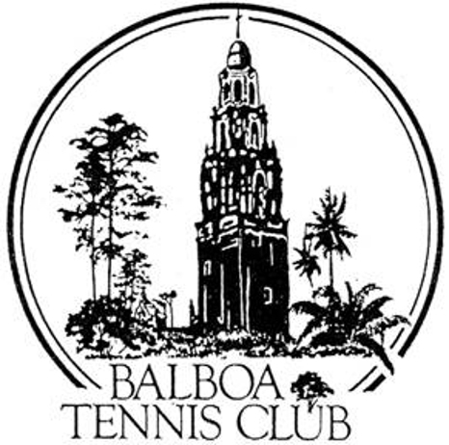
Balboa Tennis Club
Board of Directors Meeting Minutes

June 19, 2018

Meeting called to order at 7:05 p.m.

Attendees: Janene Christopher, Gary Smith, Julia Gregory, Andrew Macfarlane, Esther Leeflang, Geoff Griffin and Colleen Clery Ferrell. M.A. Hillier called in and participated via telephone. Ruben Carriedo is in Europe. The Board started the meeting by taking a tour of specific garden areas around the Club.

The May 2018 meeting minutes and absence were approved unanimously.

Member/Guest presentation – None

President's Comments (Janene Christopher) –
- Press Pavilion update – The City has approved drawings. Next step is to submit plans for permit in August. Hope to break ground after tournament season in November.

Tennis Director’s Report (Geoff Griffin)
- Geoff spoke about honor from receiving the Ben Press Award. He recapped Tennis Fest 2018 saying that it took four people to do the job that he and Manuela did in previous years. Committee didn’t include fundraiser or goodie bags, yet did compensate tennis pros with gift card and lunch. Overall Tennis Fest was well attended once again, even attracting SCTA officials to see how San Diego runs the event.
- Wounded Warrior camp went really well. Only venue that let the camp down was San Diego Zoo which didn’t offer bus tour. Geoff thanked the Board for Club involvement.

Club Director’s Report (Colleen Clery Ferrell)
- Free Clinic initially had 24 signups and dropped down to 12 on the actual day. Three members were signed up at the end of clinic.
- National Open was excellent event overall except for one irate mother who disagreed with seeding and went to National officials to question the placement of players. Tournament committee showed valid verification for seeding positions. Tournament financials will be presented at July Board Meeting.
- Men’s Ladder for BTC proposed by member Larry Calder. He will arrange and monitor results. 1-2 courts maximum to start. Ladder approved 5-1.
- Solar in the stadium is being explored. Colleen will research the possibility and report back at next meeting.
- Tickets for “Tennis Night at Petco Park” selling through Reservations Desk. Will segue into Aviator ticket sales for match on Saturday, July 30.
- During reading of Daily Log notes, question came up regarding Club’s stance on giving out medicine. Conclusion came by vote of 4-0, with 2 abstained, to stock Ibuprofen, aspirin and Benadryl. Persons asking for medicine may open cabinet themselves. No juniors are allowed to use medicine cabinet.
- Membership totals remaining consistent at 1364.

Committee Reports
- Budget and Finance (Julia)
Budget to Actual for May shows 430% of budgeted income from court rental and 54% from Daily Permits. Membership income at 103%. Budget for membership at 21,161 and actual came in at $21,800 – very close – difference of $639. Overall, Club over budget for income by $4000 in May. Expenses for maintenance online at $2600. Credit card fees high due to heavy usage. Utilities budgeted at $3700 and came in at $2500 – good news overall.
- Facilities - Dan’s proposal for additional landscape containers introduced to Board at beginning of meeting with garden tour. Vote delayed to July meeting so membership can be informed first.
- Constitution and Bylaws – Happy 96th birthday BTC. Born in 1922.
- Employment and Personnel – None
- Ethics – None

Contract and Lease

- Cafe – Additional sink required for permit pricey. Guillermo looking for better deal. Board encouraged Colleen to add popular items to weekly Club Update.
- Lease – Lease with City expires 5/1/19.

Other Issues
- Newsletter – Will be published in November 2018. Geoff suggested writing article on Spike Lowndes.
- Website – Donation button for Upper Court Lights added.
- Advertising/Public Outreach – None
- Fundraising – Club searching for ideas to help raise money for Upper Court Lighting Program.

Unfinished Business
- Indemnity letters - Confirmed sending to SDDTA, GSDCTC and Griffin Tennis for usage of rooms in Reservations Building.
- Memorial Day Parade – Esther reported the BTC group was a “crowd favorite” as they created a moveable tennis court while strolling down the streets of Kensington.

New Business - None

Adjournment: 8:35 p.m. Executive Session to follow

Next board meeting will be July 17, 2018

