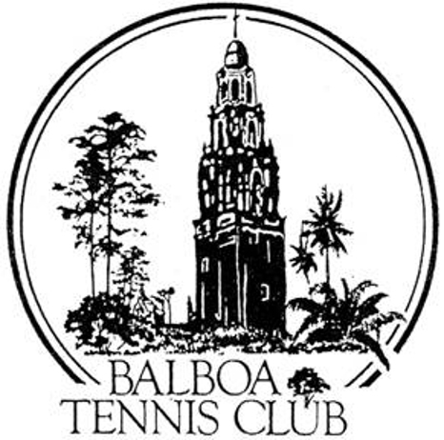
Balboa Tennis Club
Board of Directors Meeting Minutes

May 23, 2017

Meeting called to order at 7:02 p.m.

Attendees: Janene Christopher, Gary Smith, Julia Gregory, M.A. Hillier, Andrew Macfarlane, Esther Leeflang, Ruben Carriedo; Colleen Clery Ferrell, Geoff Griffin and Julie Prichard.

The April 18, 2017 meeting minutes were approved unanimously.

Member/Guest presentation – Guillermo Sanchez spoke regarding his wishes and plan for the café. He hopes to sell craft coffee, ice cream, sandwiches, fruit salads and other foods as requested by customers. Guillermo now works as a manager at the Cheesecake Factory and in the past has worked with opening and operating four coffee shops. He lives locally and has seen several attempts and failures of buisenesses at the café location. He would open seven days a week for a year and try to bring outside business through social media exposure.

President's Comments (Janene Christopher) – none

Tennis Director’s Report (Geoff Griffin)
- Spring tournament entries increased due to players registering online.
- Wounded Warrior event was a success, yet a lot of work.
- Tennis Fest was the “best ever.” Presence of Dick Enburg and Pam Shriver added prestige to the event. However, the local pros participation was down. Thanks to volunteers including high school students for stepping in to assist in place of pros.
- Georff has run Tennis Fest for 17 years. This past event is Geoff’s last. SD District will continue event next year. Geoff recommends BTC play the key role in planning.
- Tennis Fest gifts and charity auctions all successful. $6,000 raised for charity.

Club Director’s Report (Colleen Clery Ferrell)
- Traveled to new USTA facility at Lake Nona. Encouraged by new and young team running facility and USTA in general. She learned helpful tips for running future tournaments.
- The club purchased a PA system to be used by the tournament desk. A large monitor will display scores as they are reported. Discussed option to add player names to tournament courts, as done at Barnes Tennis Center, but no decisions made.
- BTC purchased 40 tickets for July 22 Aviator match at $30 each. Last year this was a very popular club event.
- The city has promised to come to do tree trimming, work not yet completed.
- Clubhouse roof – we are a low priority for the city. No decision from Board regarding Club paying for repair.
- Recent aggressive dog situation resolved.
- New membership log shows more details regarding specific categories and totals. These numbers are built in from Tennisbooking.com

Committee Reports
Budget and Finance (Julia)
- Our cash on hand is $126,000, which is much better than goal of greater than $50,000.Concern about borrowing terms if club were to finance lighting. Suggestion to pay for new LED lights on courts 9 and 10 as showcase.
- Annual budget on target so far for year. Revenue was slightly underestimated and expenditures are in line. The hope is that with the addition of the Jack Grace money due at end of year, and the phasing of the LED lighting, that the lighting can be self-financed. Julia is not in favor of borrowing money to finance projects.

Facilities (Janene)
- Lighting measurements were conducted on the lower courts and upper courts to determine the current lighting situation. As expected, lower court lighting is good and levels of light on upper courts are very low.
- Kirk from G-Force Lighting will provide examples of local courts that have recently upgraded to LED lighting so we can evaluate options.
- Court 1 (teaching court) and Stadium do not have shade/awning for players to rest. Will get estimates as to costs.
- Tournament pavilion – next step is drawings. Estimate is approx $10,000 total. Julia recommends we review rules for when form RFP required.
- Jesse Menczer has assisted with lighting project plans. Will assist in measurement of current light situation and with negotiation of proposals.
Constitution and Bylaws – none
Employment and Personnel – none.
Ethics – none
Contract and Lease
Cafe – Ohana will open for large events the remainder of the year, but will otherwise not be open and will not be operating at BTC after 2017. Ohana offers to sell furniture and equipment to the Club. BTC will review what changes are required to bring café to code for new occupant.
Other Issues
Newletter - Published
Website – Membership renewal updated to include waiver and indemnity to club.
Advertising/Public Outreach – none
Fundraising – none
Unfinished Business
Lifetime memberships – Accountant recommends against offering.
Racquet War – Company willing to work with BTC requests. Tournament is likely to move forward for April 2018.
New Business
Reschedule November Board Meeting to November 28 - Approved
Dave Felice Letter – Read to Board with no response.
Adjournment: 8:30 p.m.
Next board meeting will be June 20, 2017

