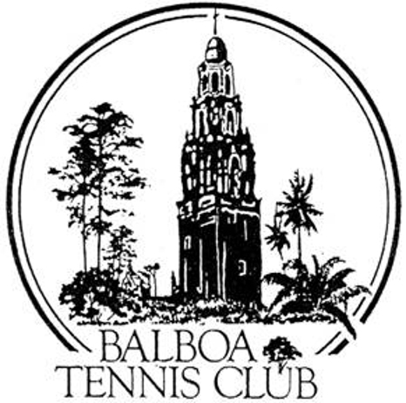
Balboa Tennis Club
Board of Directors Meeting Minutes
November 26, 2019

Meeting called to order at 6:30 p.m. by President Janene Christopher

Attendees: Janene Christopher, Remy Serrano, Gary Smith, M.A. Hillier, Todd Linke, and Colleen Clery Ferrell. Andrew Macfarlane and Ruben Carriedo were not in attendance. The October 2019 meeting minutes and absences were approved - MMS&C

Member/Guest presentation – None

President's Comments (Janene Christopher)
- Press Family Tennis Pavilion and Maureen Connolly Brinker Dedication Ceremony went well.
- Board members made a visit outside to look at the Ben Press Wall in order to make a decision on Spike Lowndes request for additional verbiage.( under New Business)
- Overview given regarding front gate concept with laser designs, which will be unique. Moving forward with fencing in the heart of the Club.
- Chilling unit to be installed for water dispenser in Press Family Wall.
- Request to see total invoice from G Force Construction for Upper Court LED Lighting Project, including bid and costs.

Tennis Director’s Report (Geoff Griffin) – No longer required to attend meetings - Club waiting on signed contract for 2019-2021

Club Director’s Report (Colleen Clery Ferrell)
- The USTA Grant application has been very tedious and time consuming process. No guarantees on funding as previously reported.
- With help from Jack McGrory, the Club found a way to accept the 100 K donation from Una Davis. The San Diego Foundation will receive the grant and send through Balboa Park Conservancy, which is a 501c3. They can receive and grant back to as a Balboa Park upgrade.
- A neighbor who lives across the street from the Club complained about noise from the blowers used by the gardeners. Blowers will be started as late as possible and from area furthest away near court 18 to diffuse possible noise effect on neighborhood. It was noted that SD City workers also use blowers in the morning around the Club – not just BTC gardening crew.
- Men’s Ladder organized by Larry Calder thriving and bringing in new members. Court usage controlled every week to maximize court time by all members on Thursday morning.
- Colleen read a thank you note from Nancy Sanchez regarding Intersectional Sponsorship money.
- Membership total at 1470

Committee Reports
- Budget and Finance (Colleen)
  - $116,953 in the bank.
  - October daily permits down $502, memberships steady, court rental up from Geoff’s Junior Satellite and K&W rental. Income matches last year at 28K, yet expenses higher. Net income for month finished at -4643.
  - YTD income up 10k in court rental. Memberships have rebounded greatly since winter months when Club was way down with rain and currently stands at 229K. Daily permits down as a result of increased outside court rental, which gains revenue yet takes courts away from non members coming to the Club looking to rent a court. On the expense side, janitorial and cleaning elevated from more events at BTC, merchant service fees continue to rise as more people are using credit and debit cards to pay fees and permits. Overall net income YTD is at 15,846, up $7302 over 2018.
  - Budget to Actual for October finished $2332 over budget. YTD net income finished $15,846 over budget.

- Facilities
  - BTC member Dave Felice worked on patching roof. So far no leaking from recent rains.
- Constitution and Bylaws – Three Strike Rule regarding verbal warning, written warning and ejection for club member discipline, confirmed by the Board.
- Employment and Personnel – BTC employee reviews were discussed in Executive Session.
- Ethics – None

Contract and Lease – Reviewed by Andrew, then distributed to Griffin Tennis and Route 6 Café for signage.

Other Issues
- Newsletter – Early December distribution
- Website – None
- Advertising/Public Outreach - None
- Fundraising – None

Unfinished Business
- Old vs. New BTC Logo – Janene discussed her rationale for insisting on usage of original BTC logo. She explained that most large companies and organizations use a standard logo. Colleen had logo designed for National Open Hard Court Championships that was a different style depicting California Tower. Board decided to keep using standard traditional BTC logo for most Club usage. MMSC

New Business
- Request from Spike Lowndes - Spike requested to add future son -in-law’s name to plaque currently hanging on Press Family Pavilion Wall. Denied – project is complete.

Adjournment: 7:50 p.m.

Executive Session to follow

Next board meeting will be December 17, 2019

