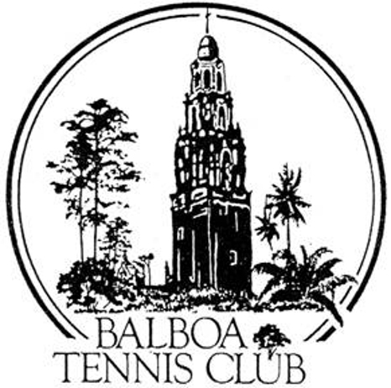
Balboa Tennis Club
Board of Directors Meeting Minutes
October 16, 2018

Meeting called to order at 7:02 p.m.

Attendees: President Janene Christopher, Gary Smith, M.A. Hillier, Ruben Carriedo, Todd Linke, Remedios Serrano and Colleen Clery Ferrell. Andrew Macfarlane and Geoff Griffin were absent.

The September 2018 meeting minutes, executive session and absences were all MMS&C

Member/Guest presentation – Two new board member candidates – Remy Serrano and Todd Linke were introduced. Each gave a brief presentation on their backgrounds and desires to serve on the BTC Board. Gary made a motion to accept the two new board members. MMS&C. The position of treasurer was offered to Remy Serrano, who has 25 years working for San Diego Superior Court in Human Resources and Data Technology. Gary made another motion to accept Remy Serrano as the new Board Treasurer. MMS&C.

President's Comments (Janene Christopher)
- Press Pavilion/Canopy update – The final plans for the Press Pavilion/Canopy have been submitted to the City for plan check. 5/7 plans were reviewed.
- BTC will receive two awards from San Diego Tennis Association at the January banquet. “Club of the Year” and “Tournament of the Year” for the improved San Diego Metropolitan. Colleen will collect names of Board members who’d like to attend. Invitations will be extended to Julia & Esther.

Tennis Director’s Report (Geoff Griffin absent) Pertinent information to be covered in Executive Session Minutes.

Club Director’s Report (Colleen Clery Ferrell)
- Quote on Maureen Connolly Brinker paver –Quote came in at $8500, waiting to hear from family.
- Pavers - 11 pavers have been purchased and will be installed in near future.
- Glow in the Dark Tennis Update – Currently on hold.
- Padded high back chairs in the Clubhouse – Over half have loose legs which cannot be tighten. Janene will look for / suggest replacement chairs prior to next meeting (will distribute via e-mail).
- November Board Meeting Change – Colleen requested a date change for November Board Meeting [to 11/27/18], due to participation at Inter-sectionals. MMS&C.
- OLP Track Team – Using BTC Restrooms during workouts at Morley Field. Will contact tennis coach and advise then that the Club’s Toilet room is only for the Tennis Team.
- Membership numbers – Steady at 1,362.

Committee Reports

- Budget and Finance (Colleen)
  - $124K in the Club bank account.
  - SD Metropolitan tournament income and expenses recognized in Sept. of 2018 instead of October, as in 2017, so budget numbers skewed.
  - Additional facility expenses included net between courts 2&3 and ball mower for teaching courts, which were all previously approved by the Board.
  - Income from Metropolitan Tournament increased $600 over 2017.
  - Overall, YTD budgeted income up $10,917.
  - Budget for 2019 will be presented at November meeting and approved at December meeting.
- Facilities – Fence behind south side of backboard area replaced. Janene requesting rock infill be placed in the gap between the fence and the slab. Rock/gravel should be level w/ conc slab to prevent uneven surface/change of plane.
- Constitution and Bylaws – None
- Employment and Personnel– None
- Ethics – None

Contract and Lease
- Cafe – Still waiting on final approval from the Health Department.
- Lease– Lease with City expires 5/1/19.

Other Issues
- Newsletter– Publication in November 2018.New board members will be featured.
- Website– None
- Advertising/Public Outreach – None
- Fundraising for LED lights – We need at least $180K
  - Janene would like to have the BTC Spring Tournament be a fundraiser – charging a higher entry fees – Participants get t-shirt that could say “They Gave to the Light” or some other witty phrase. Glow in the Dark shirt [more discussion needed]
  - Charter Memberships - $10K for life membership + custom plaque on light pole, [more Discussion needed].

Unfinished Business
- Feuds on the Challenge Court – Follow-up to what was sent out on weekly-Update regarding poor behavior. 3 strike approach for members who receive complaints.
- BTC Logo – Janene passed out layout of all 8 logos created by Andre Lalias for feedback. No consensus on one logo as being the best. All members had ideas for modification.
- Consent Agreement – Agreement between BTC and Griffin Tennis regarding the existing logo. TBD
New Business
- Solicitation for bids – Janene passed out draft of the Solicitation for Bid for the canopy. Once the plans have full plan check approval, this document will be used to solicit bids from Contractors. Construction will be done in $25,000 increments to stay under prevailing wages umbrella as dictated by our SUP. MMS&C to use document for Solicitation.
Adjournment: 8:45 p.m. Executive Session to follow. Next board meeting will be November 27, 2018

