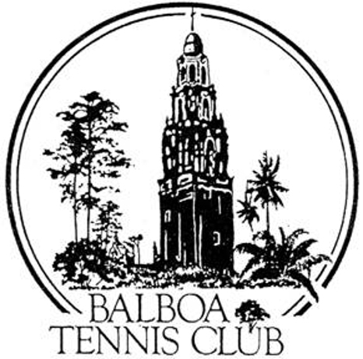
Balboa Tennis Club
Board of Directors Meeting Minutes

September 19, 2017

Meeting called to order at 7:00 p.m.

Attendees: Janene Christopher, Gary Smith, Julia Gregory, Andrew Macfarlane; Esther Leeflang, Ruben Carriedo; Colleen Clery Ferrell, and Geoff Griffin.

M.A. Hillier was in attendance via phone.

The August 15, 2017 meeting minutes were approved unanimously.

Member/Guest presentation – Carla Zarbo and Margaret Mansell from Mountain View Tennis Club (MVTC) requested to sell tickets for an upcoming fundraiser at the upcoming Metropolitan Tournament. MVTC wishes to raise money for a new trailer with bathrooms and other club upgrades. Esther made a motion and the board unanimously approved MVTC members selling tickets at the Metropolitan Tournament.

President's Comments (Janene Christopher) –
- There is a new sign for Morley Field at Texas and Upas intersection that was installed by the City. Board members like the sign and asked if BTC could get a similar sign. Plan to email Susan Mendoza, Club District Manager with city, to request BTC be put on list for new sign.
- Janene visited other local clubs to view lighting poles, evaluating effectiveness and apparent safety of poles between courts.

Tennis Director’s Report (Geoff Griffin)
- Two new pros added to staff: Jerry Sabio and Sean Ortuno. Both have been additionally insured through Geoff Griffin’s USPTA policy.
- Branches hanging over court 1 are dropping berries and causing problems on the court. City to be notified to request trimming branches.
- During resurfacing, Geoff and pros will use other courts as needed to accommodate pros and clinics. Sheds will be moved during resurfacing projects.

Club Director’s Report (Colleen Clery Ferrell)
- Unianimous approval for intersectional stipend of $50 per player. Approximately 10 BTC members are expected to go.
- Tree trimming near courts 10, 16-18, 22-24 completed last month.
- Contract for CIF tournament completed. Contract for 1 year, boys and girls CIF team and individual championships will be played at BTC.
- There was a discussion regarding logo wear being sold at BTC and potential conflict of interest with Griffin Tennis. Racquet War and CIF high school groups both wish to sell clothing with respective logos during their events. Geoff will discuss with each entity as to what they will sell, where sold etc.
- Article about Balboa Tennis Club with comments from Geoff and Colleen will appear in future Inside Tennis magazine issue.
- SD Tennis Federation requested pricing for canopy ($2500) to cover the remaining space between courts 8 and 9. Federation may assist with funding.
- Membership is holding strong at 1243.
- Checklist for janitorial service developed. Hope is for checklist to improve consistency so that all tasks are completed each day.
- M.A. raised question regarding puddles on surface by backboard. This area is within scope of BTC’s Special Use Permit, which designates this area should be maintained by BTC. Geoff requested leaf blowing start at Court 1 in the morning so teaching courts will be completed early and blowing causes less interference with morning lessons.
- Esther request that tables by courts 19 and 22 be wiped down each morning by janitorial staff.
- Colleen will follow up with cleaning service regarding these requests.

Committee Reports
- Budget and Finance (Julia)
  - Favorable quote of $33,960 received for resurfacing courts 1-4, 11-12 and Stadium. Resurfacing will begin Mon Oct 2 after Metro Tournament is complete.
  - Extra $5,000 income past month due to girls 16/18 Nationals tournament court fees.
  - Daily permits down slightly, probably due to girl’s tournament usage.
  - Credit card fees are higher than budgeted due to increase of payments via credit card. Future budget will account for increased credit fees.
  - SDGE bill higher than budget.
  - Overall, Julia reported finances are “all good.”

- Employment and Personnel – Sean is now working with Griffin Tennis, yet will keep one shift at Reservations. Rob is hired again and working Saturday mornings.
- Ethics – None

Contract and Lease

- Cafe – Becky will vacate café on Oct 1. She will take her outdoor furniture and freezer.
  - Guillermo Sanchez set to take over. Plan is for coffee, smoothies and sandwiches.
  - Need to bring café to code and acquire necessary permits.
  - Guillermo’s goal is to open in Jan, starting with 9am to 2pm daily.

Other Issues

- Pavilion – Janene completed architectural drawings with 4 options including cantilever covering to minimize poles/posts. $56,000 estimate to complete with initial design including proper roof with mutliple supporting poles. Approximately $20,000 available. Discussion as to additional sources of revenue to complete project including possible grants from the San Diego Tennis District and GSDCTC. Need to find out how much the Press family is willing to contribute. Board decided to stay with permanent structure for tournament pavilion that matches current architectural style of BTC buildings.
- Board thanks Julie Pritchard for her service to club with social media start up and management. Letter requested from BTC Board will be mailed to Julie Prichard.
- Café chalkboard – thanks to Palia Griffin for drawings. Board approved stipend for additional drawings in the future and wants another chalkboard installed after new cafe operator takes over.
- Christopher of Babycakes asked about lifetime membership after hosting business at club café in the past. Board agreed to offer renewal rate but not lifetime membership.
- USTA’s program -Tennis on Campus - requests holding a tournament at BTC the weekend of Februar 9-11 2018. 16 courts will be used for tournament, from Friday - Sunday. Approximately $3,500 revenue to club. Motion made and board unanimously approved court rental for this tournament.

Adjournment: 8:32 p.m.

Next board meeting will be October 17, 2017

